**Dunning Proposal and Activity**

**T Codes:**

**FPVA:** To create a Dunning Proposal

**FPVB:** To perform the Dunning Action

**Defining a Dunning Proposal**

Step 1: Navigate to the dunning proposal screen using the **T Code: FPVA** and give in the required details

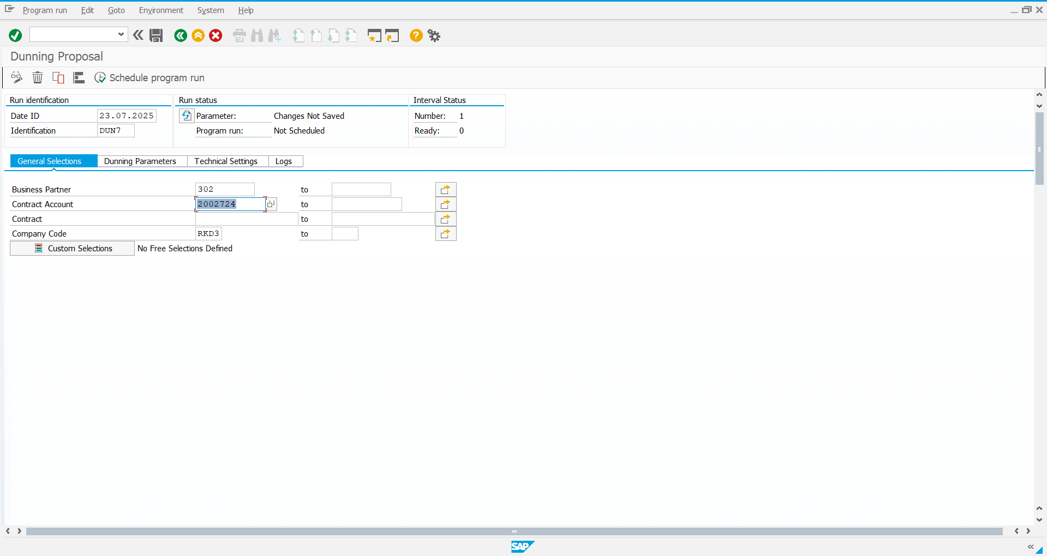

Step 2: Define the Dunning Parameters and save it

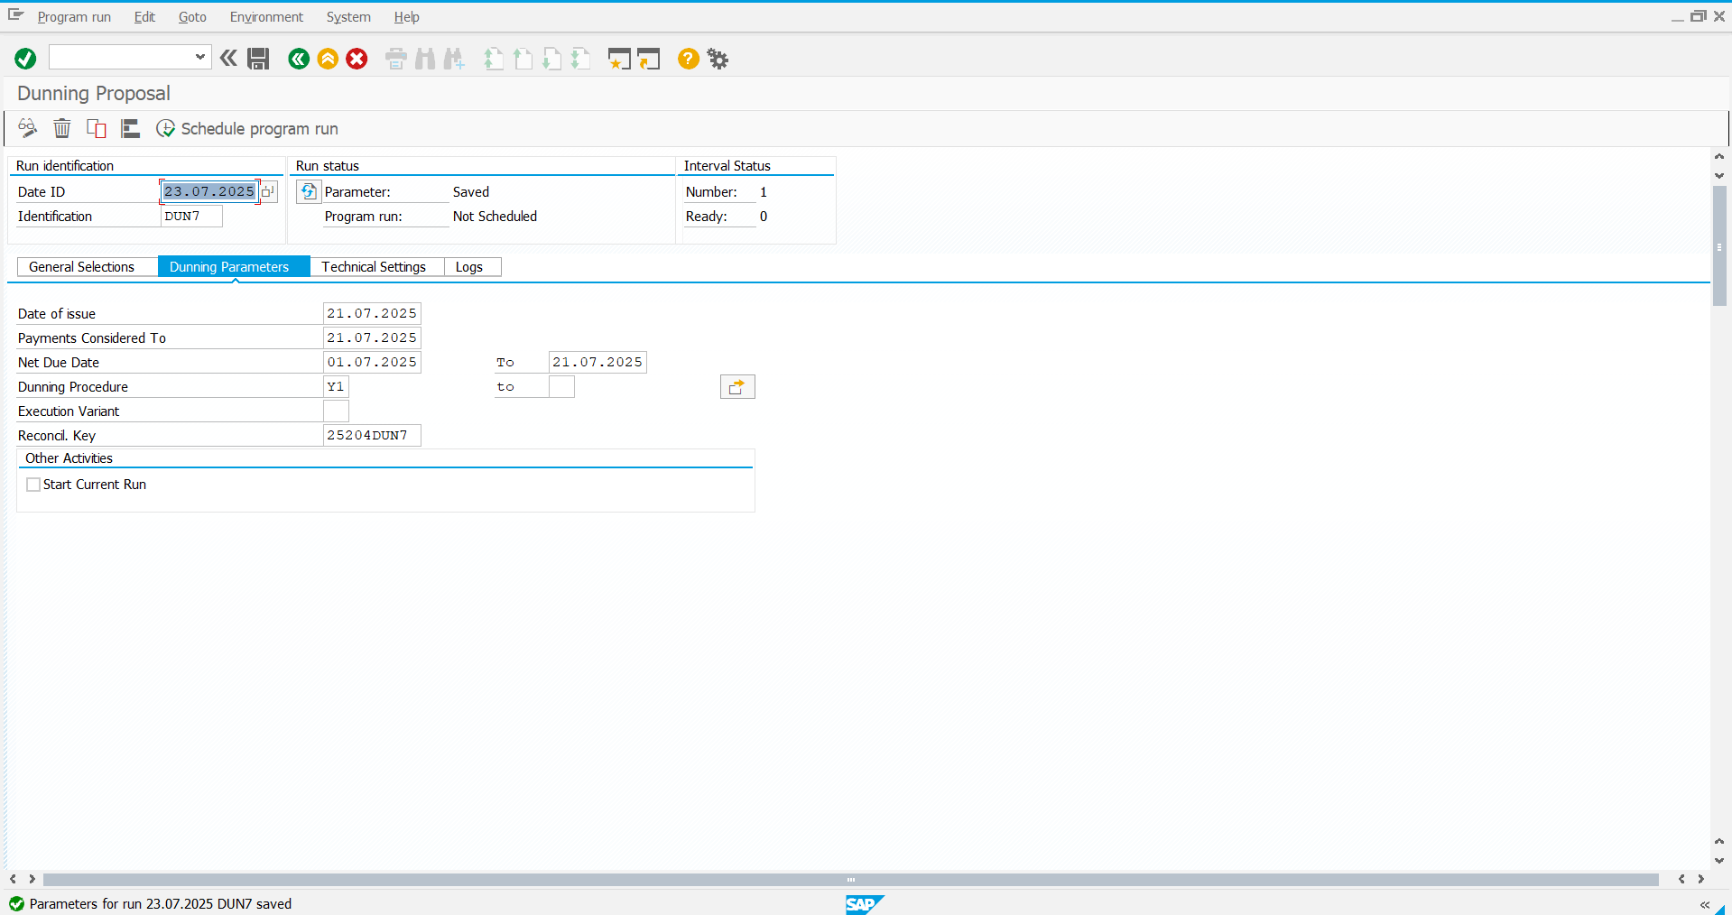

**Define the Dunning Activity**

Step 1: Navigate to the Dunning Activity screen using the **T Code: FPVB**

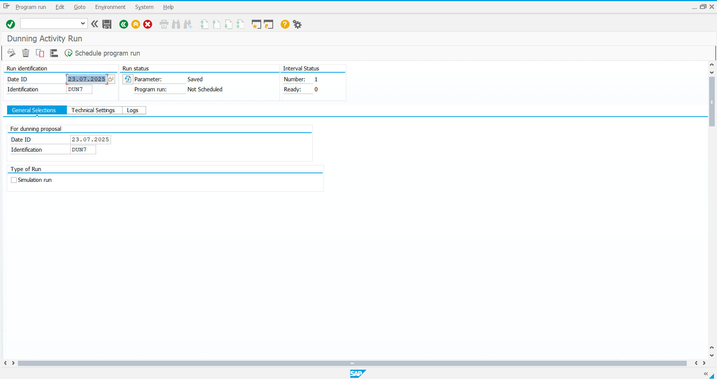

Step 2: Schedule the Program Run

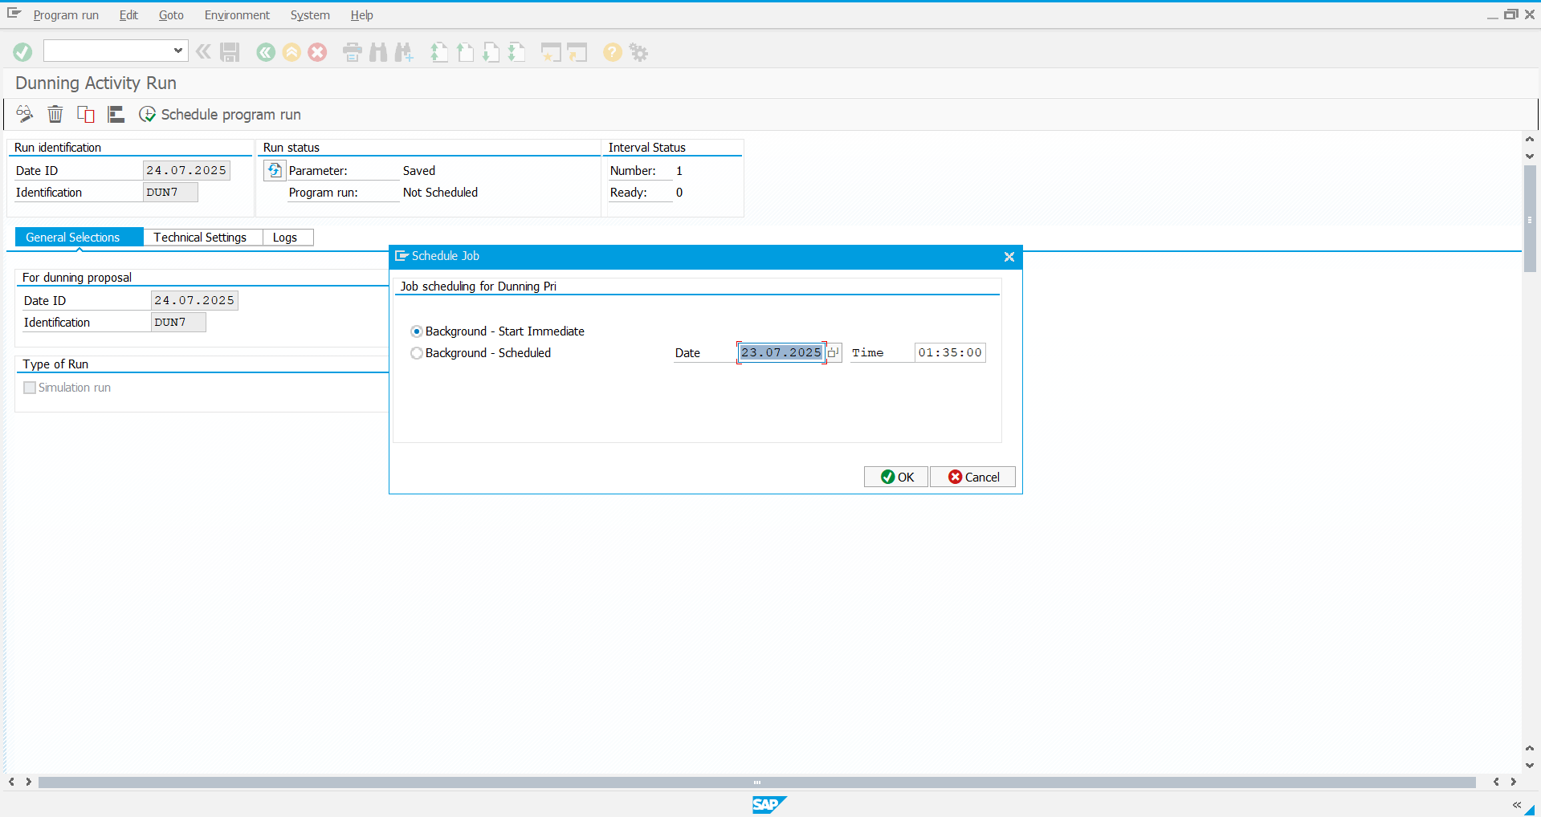

Step 3: The program run is complete:

